**ECS 204: SIGNALS AND SYSTEMS**

**PROGRAMMING ASSIGNMENT**

NAME: Ishanya

ROLL NO: 21329

DATE: 18th April 2023

**QUESTION.1)**

a.) AM involves the superposition of a low-frequency signal (the modulating signal) onto a high-frequency signal (the carrier signal) to produce an AM signal. It is used in analog communication systems to transmit information over a carrier wave by varying the amplitude of the carrier wave in accordance with the amplitude of the modulating signal. The resulting waveform has the same frequency as the carrier signal, but its amplitude varies in proportion to the modulating signal.

The process of AM involves three stages: modulation, transmission, and demodulation. During modulation, the information signal is used to vary the amplitude of the carrier signal, resulting in the AM signal. The AM signal is then transmitted through a communication channel (such as a radio wave or a cable), which may introduce noise and distortion. Finally, during demodulation, the original information signal is recovered from the AM signal by detecting the envelope of the signal using an envelope detector or similar circuit.

AM signals are used in various communication applications, including broadcasting, two-way radio, and aircraft communication. Here the AM signal can be demodulated by extracting the envelope of the signal to recover the original modulating signal.

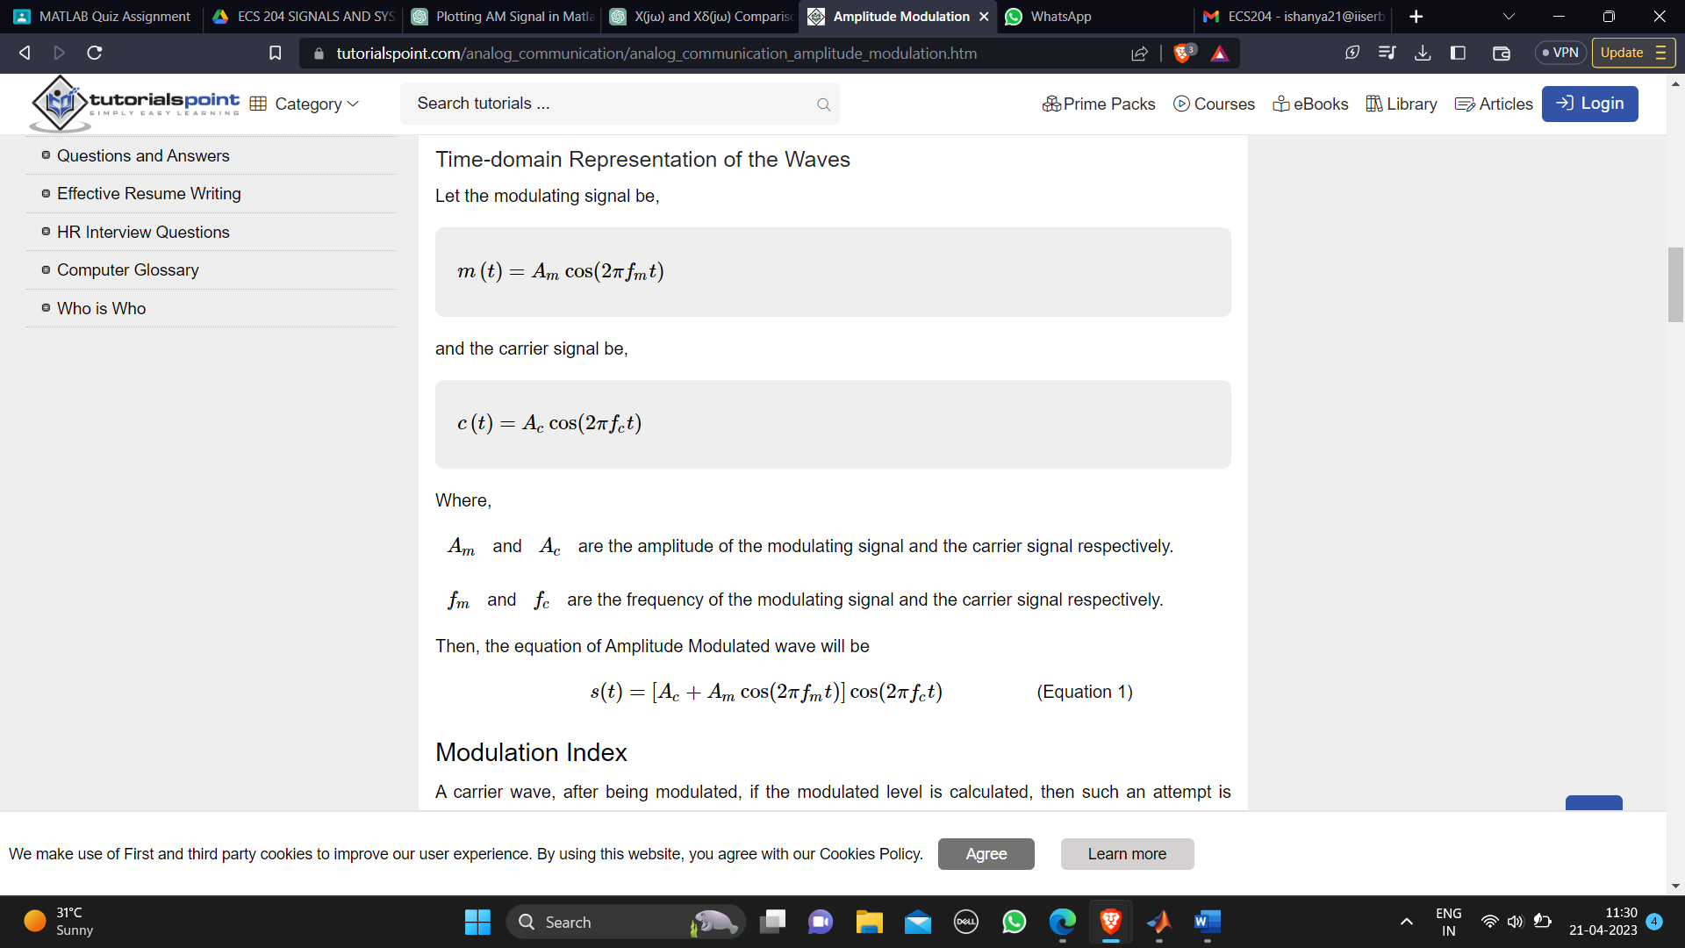

**2. MATLAB Code**

% Name: Ishanya

% Roll number: 21329 (values taken 1329)

fs = 1329;

fc = 1329/2;

fm = 1329/4;

Ac = 1;

Am = 1;

t = linspace(0, 1, 0.1*fs);

% Define the modulating signal

m_t = Am*cos(2*pi*fm*t);

% Define the carrier signal

c_t = Ac*cos(2*pi*fc*t);

% Calculate the modulated signal

s_t = m_t.*c_t;

% Plot the modulating signal

subplot(4,1,1);

plot(t, m_t);

xlabel('Time (s)');

ylabel('m(t)');

title('Modulating signal');

% Plot the carrier signal

subplot(4,1,2);

plot(t, c_t);

xlabel('Time (s)');

ylabel('c(t)');

title('Carrier signal');

% Plot the modulated signal

subplot(4,1,3);

plot(t, s_t);

xlabel('Time (s)');

ylabel('s(t)');

title('Modulated signal');

% Plot the magnitude spectrum of the modulated signal

subplot(4,1,4);

S_f = fftshift(abs(fft(s_t)));

f = linspace(-fs/2, fs/2, length(S_f));

plot(f, S_f);

xlabel('Frequency (Hz)');

ylabel('|S(f)|');

title('Magnitude spectrum of modulated signal');

**3. Output**

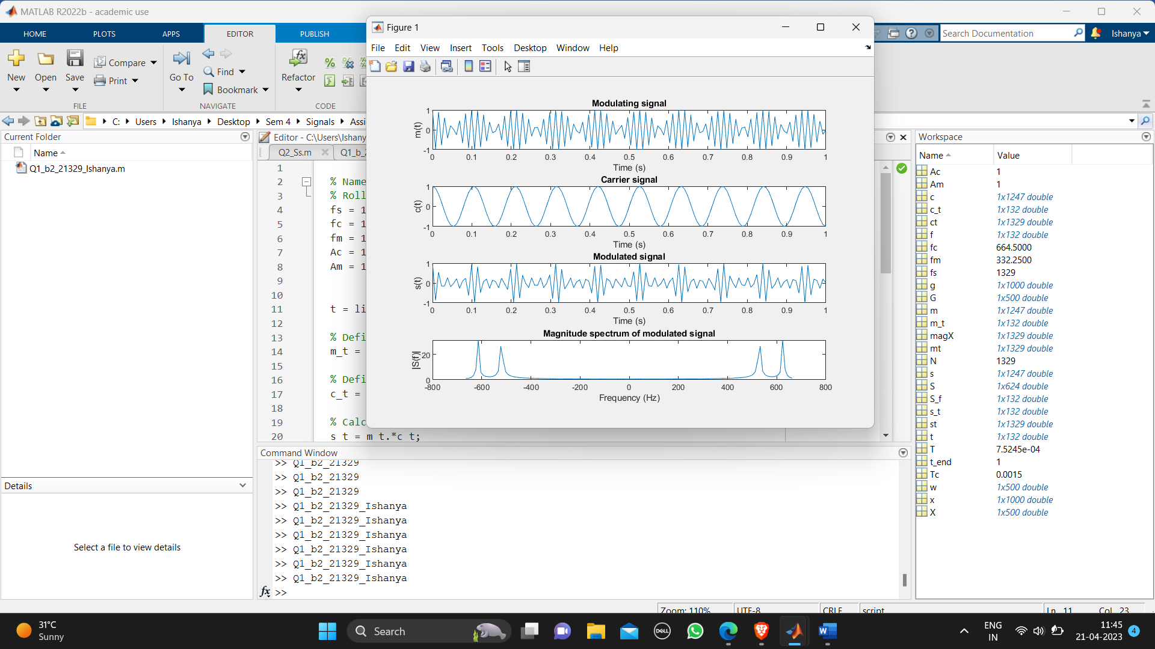

**4. Inference**

This MATLAB code simulates Amplitude Modulation (AM) using cosine wave signals.

Here's what each line does:

*fs = 1329;* sets the sampling frequency to 1329 Hz.

*fc = 1329/2*; calculates the carrier frequency as half the sampling frequency (i.e., 664.5 Hz).

*fm = 1329/4;* calculates the modulating frequency as a quarter of the sampling frequency (i.e., 332.25 Hz).

*Ac = 1;* sets the amplitude of the carrier signal to 1.

*Am = 1;* sets the amplitude of the modulating signal to 1.

*t = linspace(0, 1, 0.1*fs);* generates a time vector from 0 to 1 second with a step size of 1/(10*fs) seconds.

*m_t = Am*cos(2*pi*fm*t);* generates the modulating signal as a cosine wave with a frequency of fm.

*c_t = Ac*cos(2*pi*fc*t);* generates the carrier signal as a cosine wave with a frequency of fc.

*s_t = m_t.*c_t;* modulates the carrier signal with the modulating signal to produce the AM signal.

*subplot(4,1,1);* plot(t, m_t); xlabel('Time (s)'); ylabel('m(t)'); title('Modulating signal'); plots the modulating signal in the first subplot.

*subplot(4,1,2);* plot(t, c_t); xlabel('Time (s)'); ylabel('c(t)'); title('Carrier signal'); plots the carrier signal in the second subplot.

*subplot(4,1,3);* plot(t, s_t); xlabel('Time (s)'); ylabel('s(t)'); title('Modulated signal'); plots the modulated signal in the third subplot.

*subplot(4,1,4);* S_f = fftshift(abs(fft(s_t))); f = linspace(-fs/2, fs/2, length(S_f)); plot(f, S_f); xlabel('Frequency (Hz)'); ylabel('|S(f)|'); title('Magnitude spectrum of modulated signal'); computes the magnitude spectrum of the modulated signal and plots it in the fourth subplot.

Overall, this code demonstrates how AM works by multiplying a carrier signal with a modulating signal to produce a modulated signal that has sidebands (i.e., frequencies above and below the carrier frequency). The magnitude spectrum shows the carrier frequency and the two sidebands at fc-fm and fc+fm.